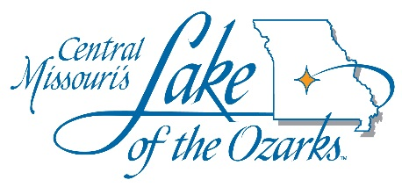
LAKE AREA BUSINESS DISTRICTS OF CAMDEN, MILLER AND MORGAN COUNTY
Event Funding Request Form – Post Event

This form must be completed and returned no later than sixty (60) days after the conclusion of your event to be eligible for future funding. Please include all receipts to show how the funds were spent to promote/market the event.

Date: _______________

Event Name: _______________________________________________________________________

Dates of Event: _____________________________________________________________________

Name of Person Completing this Form: __________________________________________________

Attendance Stated in Original Funding Request: ________ Actual Event Attendance: ________

Estimated Overnight Rooms in Original Funding Request Form: ______________________________

Actual Room Nights Generated from the Event: ___________________________________________
(Number of overnight rooms times the number of nights stayed)

In a separate document please list the actual Business District accommodation member facilities utilized. (Please list the name of each of the Hotels/Motels/Resorts/Campgrounds/Bed & Breakfasts/and Private Homes/Condos used by your event participants, number of people in their party, and number of overnights for each participant): _________________________________________________________

In a separate document please provide the Zip Codes for each of the event participants: ____________

Amount of Funding Approved by Lake Area Business District: _______________________________

Explain how the funds were used to market/promote the event: _______________________________
__________________________________________________________________________________
__________________________________________________________________________________
__________________________________________________________________________________

Date Received by the Business District: _________________________

Please return completed form and receipts to the Business District that provided funding:
Lake of the Ozarks Area Business District of Camden County Camdencountybusinessdistrictmo@gmail.com

Lake of the Ozarks Area Business District of Miller County
millercountybusinessdistrict@gmail.com

Lake of the Ozarks Area Business District of Morgan County
morgancountybusinessdistrict@gmail.com

