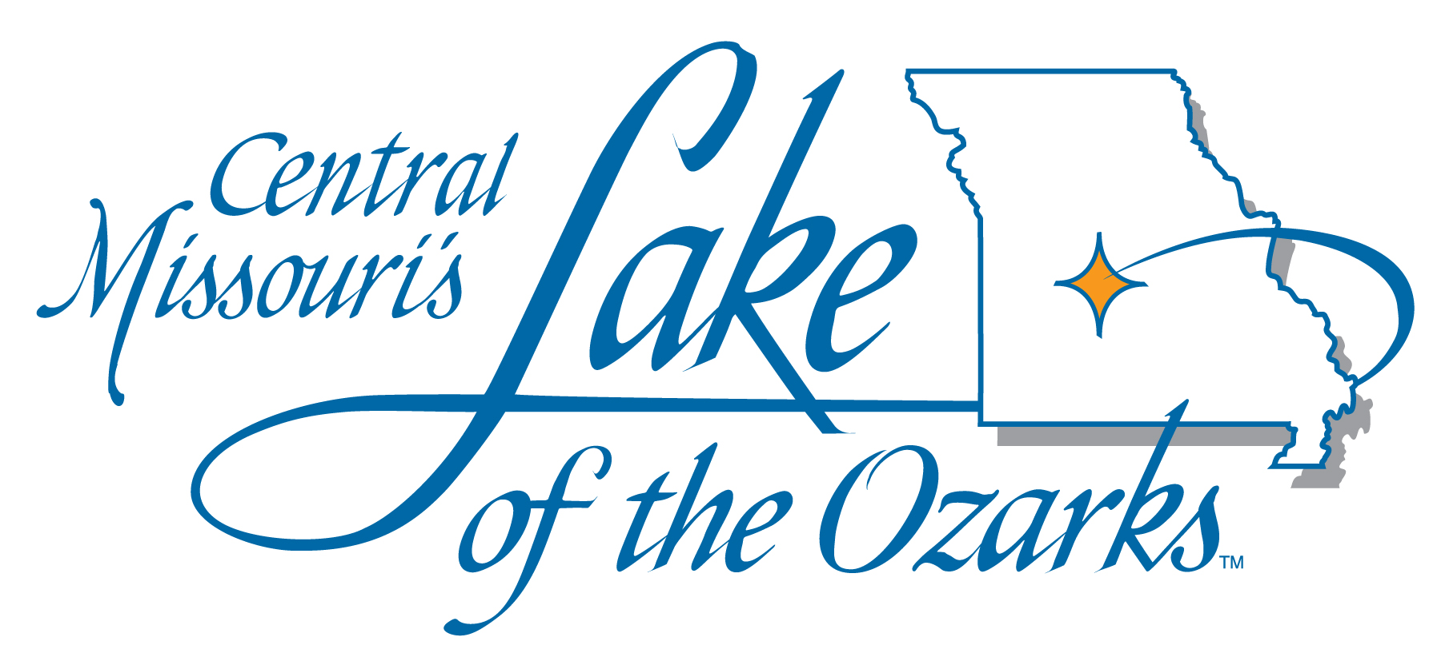

LAKE AREA BUSINESS DISTRICTS OF CAMDEN, MILLER AND MORGAN COUNTY
Event Funding Request Checklist

Thank you for your interest in submitting a funding request. Below you will find a Funding Request Form that must be fully completed in order for your request to be considered. We have provided on this page a checklist for you to utilize when preparing your request. If the request is not completed fully with all required documentation, the request will not be considered for funding.

NAME OF EVENT : ___________________________________ Date of Form Submission: _______

____Completed Funding Request Form

____Detailed Budget for the Event (Income & Expenses)-Must Be Provided

____Funding Request Form & Supporting Documentation must be submitted to the Business District of Camden County, the Business District of Miller County, and the Business District of Morgan County by the 5th of the month and at least ninety (90) days prior to your event in order to be considered at the monthly Business Districts Advisory Board meetings. For requests $2,000.00 and above, it is required a representative from the event be available at the monthly Business District Board Meetings and/or the TCLA Board of Directors meeting to provide information and/or answer questions.

If approved, you will be required to complete and submit a Post-Event Summary (a form will be provided) and provide receipts to show how the funds we utilized no later than sixty (60) days after the conclusion of your event to be eligible for future funding.

If approved, an invoice must be submitted to the Business District(s) that approved funding indicating whom the check is to be made payable and where to mail when completed.

If, for any reason, your event is cancelled after funds have been disbursed, said funds will be refunded the Lake Area Business District that provided the funding within thirty (30) days of the cancellation.

Should the Lake Area Business District of Camden, Miller or Morgan Advisory Board provide funding for this request, applicant entity agrees to provide a hard copy insurance binder, listing the Lake Area Business District Board who funded the event as an additional ensured entity/entity on the insurance policy for the event.

Should you have any questions or need assistance, please contact:
Lake of the Ozarks Area Business District of Camden County
Camdencountybusinessdistrictmo@gmail.com

Lake of the Ozarks Area Business District of Miller County
millercountybusinessdistrict@gmail.com

Lake of the Ozarks Area Business District of Morgan County
morgancountybusinessdistrict@gmail.com

LAKE AREA BUSINESS DISTRICTS OF CAMDEN, MILLER, AND MORGAN COUNTY
Event Funding Request

Thank you for considering the Lake of the Ozarks as a host site for your upcoming event! Please complete this form and send to the email addresses listed below. YOU MUST INCLUDE A DETAILED BUDGET FOR THIS EVENT (INCLUDING ALL ANTICIPATED REVENUES AND EXPENSES) along with this completed form.

Events Committee Mission Statement: To assist special events and festivals that generate measurable overnight accommodation room nights, and to promote the Lake of the Ozarks, with the goal of the event financially sustaining itself at some point in the near future.

Event Name: ______________________________________________________________________________

Date(s) of Event: ___________________________________________________________________________

Brief Description of the Event: _________________________________________________________________
__________________________________________________________________________________________
__________________________________________________________________________________________

Name of Person/Organization Completing Form: ________________________________________________

Phone #: _______________________________ Fax #: __________________________________________

E-mail: ___________________________________________________________________________________

Event Geographical Location: __________________________________________________________________

Host Hotel(s) for Event: __________________________________________________________________

Expected Number of Accommodation Facilities Utilized: (Please include Hotels, Motels, Resorts, Campgrounds, Homes and Condos) ________________________________________________________________________

Expected Total Number of Accommodation (Room) Nights Generated: ______________

Previous Years Total Accommodation (Room) Nights Generated: __________________

If this is a first-year event, please give past history from other locations of where overnight accommodation room nights were generated for this type of event.

Other Location(s): ___________________________________________________________________________

Number of Room Nights Generated at Other Location(s): ____________________________________________

Years Event has been in existence: ______________________________________________________________

Is this an annual event? Yes No

Is this a “For Profit” Event?: Yes No

Expected Total Attendance: _______________

LAKE AREA BUSINESS DISTRICTS OF CAMDEN, MILLER AND MORGAN COUNTY
Event Funding Request Page 2

Expected attendance from within a 50-mile radius of event: ___________________________________________

Expected attendance from farther than 50-mile radius of event: ________________________________________
Additional Funding Sources (amounts should be included in budget): ___________________________________
_________________________________________________________________________________________
_________________________________________________________________________________________

TOTAL FUNDS REQUESTED: $ _____________________________________________________

Please Specify How the Requested Lake Area Business District funds will be used:
_________________________________________________________________________________________
_________________________________________________________________________________________
_________________________________________________________________________________________
_________________________________________________________________________________________

What percentage of your advertising budget will be spent on advertising/marketing this event within a 50-mile radius of the event? __________________________________________________________________________

What percentage of your advertising budget will be spent on advertising/marketing this event
outside of a 50-mile radius? ____________________________________________________________________

Insurance Carrier: ________________________________________________________________

Please email the completed funding request form along with your budget to all three Business Districts listed below:

Lake of the Ozarks Area Business District of Camden County
Camdencountybusinessdistrict@gmail.com

Lake of the Ozarks Area Business District of Miller County
millercountybusinessdistrict@gmail.com

Lake of the Ozarks Area Business District of Morgan County
morgancountybusinessdistrict@gmail.com

To allow for proper planning, funding request forms should be submitted for review at least ninety (90) days prior to needing the funding or prior to the date of the event. Please note that the Lake Area Business Districts fiscal budget runs from July 1st through June 30th.

Received By: Date:

